QS9: STAR LAWS (Shedding Light on Astronomy)
Episode IX: How Does the Sun’s Path Across the Sky Change Throughout the Year?
Name: _________________________________________________
- The Sun always rises in the general direction of east, but it rises exactly east on only two days of the year:
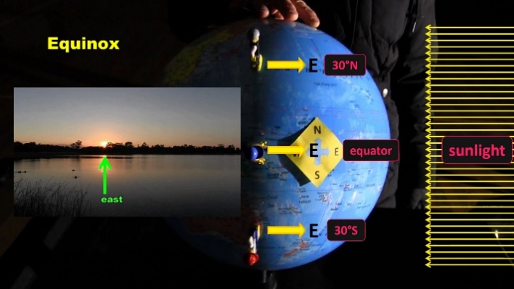
_____________________________________________________________________________________

- At the equinoxes, neither hemisphere is facing more towards the Sun, so the Sun rises exactly ______________ everywhere on Earth.

- In December, the __________________ Hemisphere is facing more towards the Sun, and so the Sun rises ______________ of _____________.

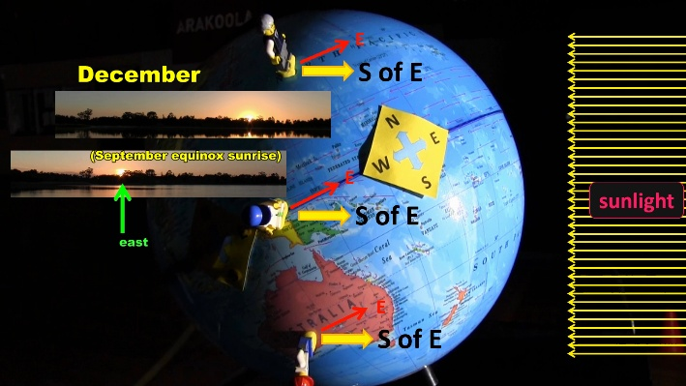
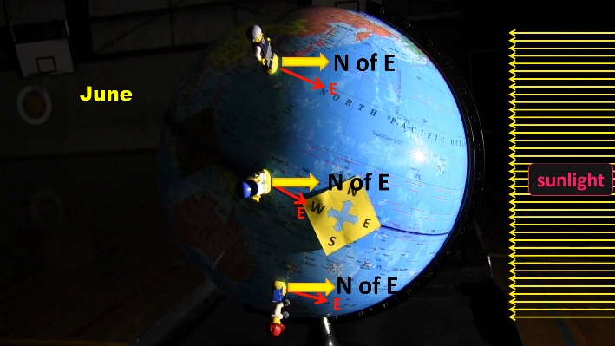
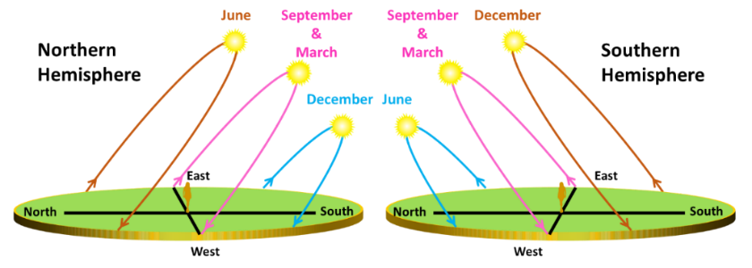
- In June, the ____________________ Hemisphere is facing more towards the Sun, so the Sun rises ___________ of ______________.

- How does the Sun’s path across the sky change between summer and winter? Include height in the sky and length of daylight. (Answer for the hemisphere that you are in.)
________________________________________________
________________________________________________
________________________________________________________________________________________
________________________________________________________________________________________
________________________________________________________________________________________
________________________________________________________________________________________________________________________________________________________________________________________________________________________________________________________________________________________________________________________________________________________________________________________________________________________________________________________________________________________________________________________________________________
- What is the elevation (also called altitude) of the Sun at sunrise and sunset? ____________________________
____________________________________________________________________________________________
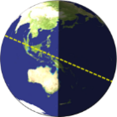
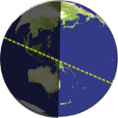

- Explain, with text and by adding to the diagram, why the shadow of a person standing anywhere on the equator at solar noon can point north or south depending on the time of year.
____________________________________________________________________________________________
________________________________________________________________________________________________________________________________________________________________________________________

- In the Southern Hemisphere, solar panels and solar hot water systems face towards the _____________ to catch the midday Sun while in the Northern Hemisphere, they face towards the ______________. (Note: This doesn’t always apply to tropical regions.)
- How does the changing path of the Sun affect what plants a gardener might place in a garden bed?
________________________________________________________________________________________________________________________________________________________________________________________________________________________________________________________________________________________________________________________________________________________________________________

